Application

Customer: Thermo Fisher Erlangen

Application: Material inspection: Non-contact measurement gauges for material thickness and coating weight

* Customer product name: "Linspector"
* Contactless thickness measurement or coating weight measurement
  + of flat materials e.g. steel, aluminum, plastics, lithium-ion battery, or nonwovens manufacturing
  + --> 1 or more linspector measurement frames are used in manufacturing lines of materials
  + From <<https://www.thermofisher.com/de/de/home/industrial/manufacturing-processing/online-non-contact-measurement-gauges.html>>
* Environments:
  + Hot steel rolling mill
  + "clean" LI-Ion battery coating and seperator film
  + Trinkverpackung

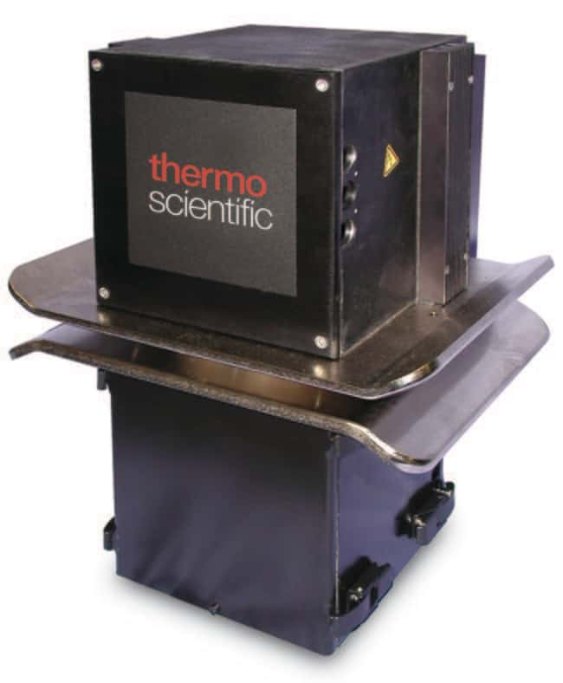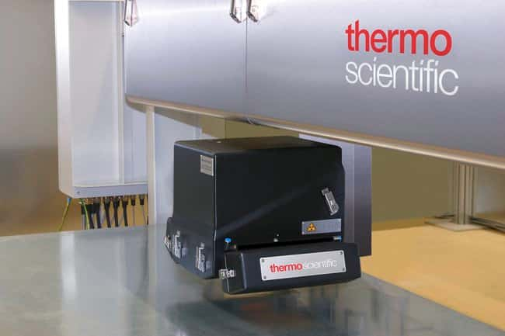

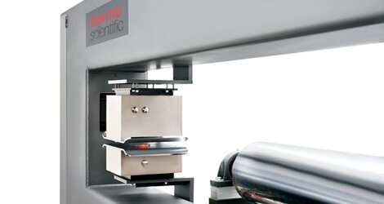

Project

Project description:

**Project name: Modular Sensorhead Enclosure Platform for TFS Linspector Thickness Gauges enabling 2nd source x-ray suppliers**

* **Sensorhead Enclosure:**Moving "box" containing X-ray generator & source and reference samples: safe, robust, reliable, position accurate and temperature stable w.r.t to significantly varying environmental conditions.
* **Retrofit with support for 2nd source X-ray suppliers:**The "new" modular concept shall support the existing Linspector range (which constrains volume claim). The aim is to be able to "integrate" multiple x-ray suppliers for a single sensorhead application (being able to use 2nd source x-ray supplies)
* **Enclosure platform:** Cover the complete range of thickness and coating weight gauges with 3 enclosure variants based on the same modular concept. Different applications (e. g. battery production vs steel rolling vs coating) require different x-ray energies and different x-ray performance (related to performance of the thickness measurement)
* **Modular enclosure:** ThermoFisher idea to have a modular approach, separating the emitter from the sample holder and from the stability measurement.

Quotation

Similar projects (for reference in quotation)

* Kulicka & Soffa Odin Camera (for pick & place machine
  + *because of the interaction between Physics & Optics and mechanics)*
* TFS Ultra-X
  + *Developing a module working with X-ray*
* Lely Youngstock Camera
  + *lifetime & environmental testing*
  + *thermal calculations*
* KnS Tapefeeder
  + lifetime testing (of drivetrain)
* *Insert other references*
  + some project with a similar thermal case

Project evaluation

* Why is this project interesting for Sioux?
  + Business strategy: It could open the door for further system level / multi-disciplinary developments within TFS Erlangen (X-ray based, non-destructive testing)
    - note STG: TFS SSH, TFS Klondike B, TFS Yukon
    - note STN: TFS Ultra-X (for TFS Eindhoven)
  + Technical content
    - insert/evaluate how interesting this is for mechanics/physics/thermal
    - x-ray domain
* What are the disadvantages of this project?
  + no concept development (we could challenge this, since it seems the maturity of the modular idea is not so high)
  + limited amount of disciplines involved (or maybe better TFS keeps ownership of system development and has split the development in several projects. Electronics and SW is done by Sioux for this project)
  + No production
  + … *what else*
* How advanced is this project?
  + *if not advanced anybody can do it,*
  + *insert evaluation by responsible disciplines*
* What is (still) needed to provide a good quotation?
  + evaluation of project by responsible discipline (mechanics + physics/optics/thermal)
  + initial project plan to make a good estimate of the required resources (what happens in w
* *Clarify*
  + Is the customer able to specify its requirements?
    - * As we know from SSH electronics / embedded SW project they need support regarding the specification. Sioux did the SRS in tight cooperation with TFS. TFS only provided a PPT at project start.
  + Is the customer able to properly accept deliveries?
    - * *it is not so trivial to specify the acceptance criteria*   
        *(lifetime, thermal,…)*
* *Concept Phase:*
  + accuracy requirements for x-ray
  + thermal performance
  + volume claim evaluation for 2nd source supplies
  + concept how to connect the modules and their interfaces (e.g. cooling water)
  + …

Project Blueprint

*structure taken from Project Blueprint Template:*[Project Blueprint Template.pptx](https://siouxeu.sharepoint.com/:p:/r/sites/CG/SystemArchitecting/Shared%20Documents/Dissemination/Project%20Blueprints/Proposals/Project%20Blueprint%20Template.pptx?d=w362dc6f9537b46dca6e8833a5b3332cf&csf=1&web=1&e=k80yye)

Disciplines involved:

* Mechanics,
  + DfX: Design for Cost, Design for Manufacturability, Assembly, Serviceability
  + Flow & Thermal,
  + Precision mechanics (?)
  + CAD & PDM
* Mechatronic System Design
  + Drive & Control
  + System architecting (limited)
  + Physics & optics (limited)
* Realization & Service
  + prototypes
  + lifetime tests
* Electronics & Embedded Software
  + Project already started April 2021 at STG. First electronics boards will be available within October / November. With current project timeline, project will be finalized ay 2022.
* Excluded:
  + ~~Assembly (production)~~

Context and History:

* **Business drivers:**
  + need for possibility to integrate 2nd source x-ray system for each sensorhead variant.
  + need for reduction of the number of sensorhead variants
    - smart selection of xray sources (e.g. energy levels corresponding to the application) should enable to reduce the number of variants and still cover the whole application range.
* **What initiates this project?**
  + unreliable and very long delivery times for x-ray sources (which are integrated in the sensorhead).
* **Why does the customer need this project?**
  + The dependence on one specific x-ray source lead to unreliable delivery times and lack of spareparts.
* Why Sioux?
  + STG already develops the new electronics and embedded software platform
  + STG is already supplier for TFS Erlangen (SSH, Klondike B, Secondment, Truedose(?)
  + STG has competences in the domain of the customer (x-ray imaging)
  + STG is located very close to TFS Erlangen
  + Sioux is capable of complex multidisciplinary developments with high demands towards accuracy
* What makes Sioux unique?
  + *insert*

Project goal, Scope and impact

* **IS (main requirements)**
  + 3 new sensorhead variants covering the complete application range
    - 3 main application domains
    - from 5 to 250kV (?)
      * desired split at 60kV
  + new modular enclosure concept of the sensorhead
    - 3 compartments: emitter, intensity check and sample
  + support of at least 2 different x-ray suppliers for a single variant
  + reliable & robust, will be used in different industrial environments
    - must be proved by lifetime and reliability testing (incl environmental effects).
    - must be robust towards vibrations
  + excellent serviceability
    - exchange of the X-ray source within max 10 min
    - weight such that
  + excellent thermal stability with severe temperature variations of the environment
    - cooling water common, customer interested in chances for peltier elements (especially for low energy variants).
    - absolute temperature variation of environment 0 to 50 deg (steel rolling mill)
    - insert requirement to thermal stability w.r.t. to optical quality
  + long shutter lifetime > 100.000 cycles
  + guaranteed x-ray safety by long life, reliable and robust x-ray shutter design
  + excellent mechanical accuracy (low deviation and variation in the optical path)
    - excellent alignment of parts
    - justage undesired
    - positioning accuracy samples in sample holder < few micrometer

dicke 0.01%  now direct drive moved to end-stop

* + motion of the internal sample holder (existing concept)
  + retrofit to existing linspector product interface (similar volume claim and interfaces)
  + small available volume will be a challenge for some variants
  + support of different x-ray sources (in the same volume)
    - possiby different source topologies (top or side ways "exit")
    - source and generator can be separate or monoblock
  + Shutter possible involves "heavy metals" (any particle contamination due to e.g. friction should be avoided)
  + Electronics and software development of the sensorhead is already ongoing at STG. Taking over also mechanics and mechatronics would result in a common (STN/STG) multidisciplinary project.
* **IS NOT**
  + dimensioning of the X-ray imaging system (existing design + components selected by the customer)
  + concept development of the sensorhead system (existing, done by customer)
  + concept for x-ray intensity measurement (existing, concept done by customer)
  + detector part of gauge (existing)
  + motion part of linspector system (existing)
  + regulatory certification: besides standard test on  emc, and x-ray safety no regulations with severe impact (?)
* Project Objectives
  + series 5 to 50 pieces a year per product variant
  + cost price of the complete sensorhead incl x-ray: 12000 (low cost variant) to 25000 euro (high cost variant)
    - cost price includes assembly costs and all components of the sensor head
    - the Xray system takes ~30 to 50% of this budget.
  + 2 of the 3 variants should be ready for series in Q4 2023
    - the 3rd variant can come somewhat later.
    - the assumption is that "milling" and prototyping production techniques are allowed. Due to the relatively low number of products/year no high volume production techniques like casting are expected.
  + FUMO's will be required (<8months) to verify
    - the thermal behavior
    - optical performance (accuracy, alignments)
    - lifetime/robustness/environmental tests
* Business decomposition
  + TFS Erlangen
    - concept & system engineering
    - system testing
    - environmental testing
    - production: coordination of production / supplier (once released for series)
    - production: final assembly and test
  + Sioux
    - Erlangen
      * sales

concept & system engineering

* + - * requirements engineering
    - Eindhoven

concept & system engineering

* + - * Design & engineering, prototyping
      * lifetime testing?
      * transfer to production
  + External supplier
    - production of components
* Work breakdown
  + mechanical concept design for enclosures consisting of 3 modules
  + coverage of enclosure variants
  + coverage of x-ray sources per variant
  + thermal concept per variant
  + design for sample holder module
  + design for intensity measurement module
* Structural Decomposition
  + sensorhead platform (Baukasten) (3 variants, each variant in X types, where each type has the same volume claim and same external interfaces (cabling, cooling, …)
    - sensorhead cover
    - Module 1: emitter
      * enclosure
        + cooling (interface)
      * optics
        + xray generator & xray source
        + collimator
        + …
        + einschwenkbare vorfilter (optional)
      * sensorhead electronics
      * external cooling interfaces
      * external electrical interfaces
      * (peltier coolers)
      * …
    - Module 2: sample holder
      * enclosure
        + cooling (interface)
      * sample holder
        + revolver mechanics
        + electrical motor
      * x-ray shutter
      * "ausgangsfenster" titanfolie
    - Module 3: (x-ray) stability measurement
      * enclosure
      * ion chamber?
    - Module 4: pivotable blind/pre-filter ("einschwenkbarer Vorfilter)
      * Between sample holder and emitter
      * Enclosure?
      * Blind/pre-filter holder
        + Blind/pre-filter
        + Electrical motor
* **Functional Decomposition (not complete)**
  + imaging systems
  + sample magazine (sample measurement 1x per shift (=1x8h)) to check spectrum of the source
    - samples have known thickness and are used with a comparison to a reference
  + Stability of the source is the most important characteristic
    - therefore the ion chamber to measure the emitting "power" (spike detection, or (undesired) changed due to temperature)
* **Project Decomposition (first guess)**
  + project manager (~40% for 1.5yr??)
  + mechanical engineer 1 with focus on mechanical aspects of enclosure (80% for 1.5yr??)
    - focus on modularity, producibility, CAD & PDM
    - support of variants
    - specification for purchase of parts
    - contact for NPI
  + Mechanical engineer (50% for 6 months ???)
    - focus on alignment, accuracy, optical properties of mechanics
  + physics / optics engineer for calculation of tolerances (<30% for 6months ??)
    - *check KnS Odin Camera project*
  + Realization and test technician
    - build up the various prototypes
    - build up FuMo (Functional Models) for the modules
  + open responsibilities
    - system/ requirements engineering (contact with customer)
      * requirements and test documents
    - mechatronics (drive & control) engineer:
      * *electrical motors are involved, but SW development is not. The current concept drives the motor towards an end-stop. Is the contribution of mechatronics trivial?*
    - integration test and verification (typical the mechatronics engineer)
    - knowledge of the x-ray system? (support to TFS for selecting x-ray sources)
* **Estimate Cost of Goods**
  + insert
* **Risks**
  + project
    - Q4 2023 unrealistic (to be evaluated by mechanics dept itself?)
    - underestimation of required mechanical resources (and no extra available resources)
    - working with Xray in Eindhoven (should be OK, also done with TFS ultra-X project, and there is knowledge and experience at STG.
  + technical
    - volume claims unrealistic when combining retrofit, modular approach and supporting multiple x-ray source types
      * *to be investigated in concept phase*
    - underestimation of complexity of System testing & integration
    - …